Rakesh Gopal Kavodkar

rgopalk

200066020

NOTE: The source code for the three problems is included as a zip file in the attachments.

Problem 1.

1. To run the profiler, we need to compile the source code with the –pg option, so that it generates the gmon.out file once we run the program. To run the profiler, we need to use the command gprof ./executable . This will give us the following result if piped to less.

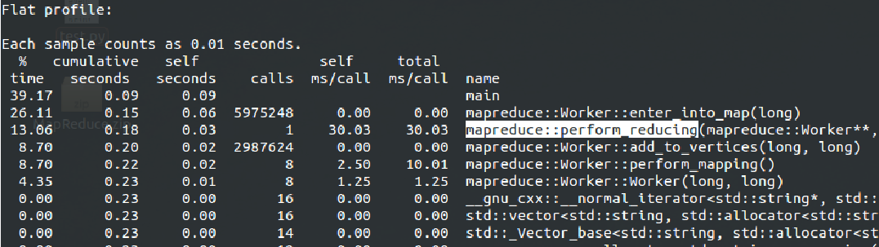

1. The above result corresponds to the youtube.graph.original file which is attached in the moodle page.

Here we see that the mapping function, viz, perform_mapping() which in turn calls enter_into_map(..) take 26.11% and 8.70% of the total time.

The reducing process takes about 13% of the execution time perform_reducing(..)

The majority of the execution time is taken is the main function. The main function has lines of code that writes the output into a file (about 30 million lines for the above mentioned graph).

The cost of IO here is almost comparable to the cost of the actual computation. Note that add_to_vertices(..) populates each of the *worker nodes.*

There is no function that takes up more than 80% of the computational time.

Problem 2.

1. We see that the Hadoop program takes more time that the C/C++ implementation.

This can be attributed to a couple of reasons.

* Hadoop writes the intermediate results to the HDFS file system. It also has a dedicated logging service that logs each and every task that is undertaken. File I/O is a considerably costly operation. In the C/C++ implementation, there are no intermediate files written, nor are there any logs.
* Even though the Hadoop ran on a single node, the implementation of the framework is for a distributed computation, and hence, it has a lot of different components like the JobTracker, TaskTracker, NameNode, DataNode, etc. Each of these components runs as a separate service. And even though the master and slave are both on the same machine and it uses the localhost address, a lot of extra computation is done to keep track of the jobs (equivalent to what would be done in a multi node scenario) and to hand over the baton to the next one in line.
* The C/C++ implementation is concise and to the point. It does exactly the vertex degree counting, unlike Hadoop which is a big framework to which we add our code, where the execution moves about through different components in different phases of the computation.
* C/C++ is way faster than Java

Problem 3.1.

Plotting the degree versus the number of nodes, we get the following graphs for the below mentioned datasets

1. Amazon:

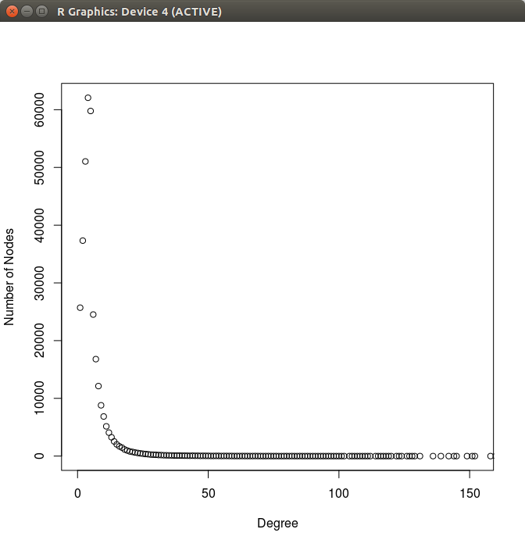

We see that this graph follows the power-law curve, and hence this is a **scale-free graph**

1. Facebook

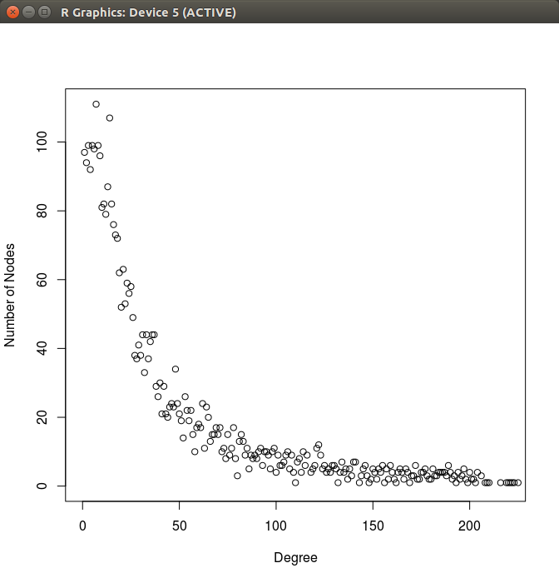

Although the points are a bit scattered, they seem to follow the power-law curve. Hence this is a **scale-free graph**

1. **Google**

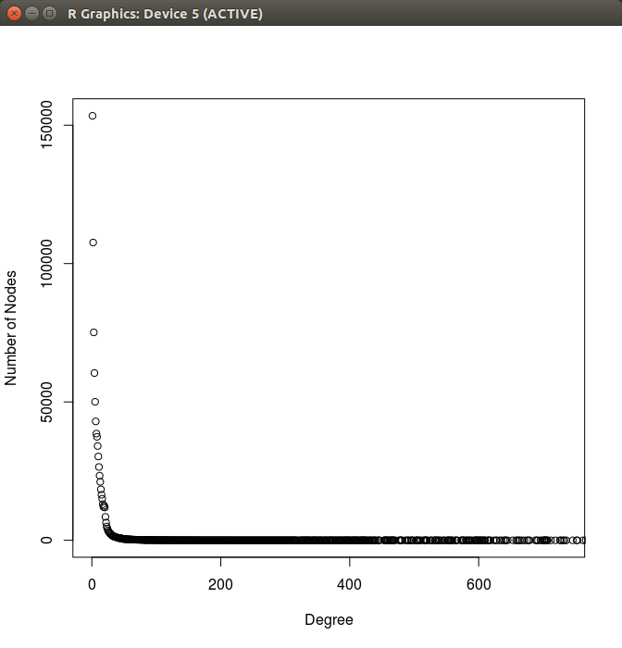

Google’s dataset also follows the power-law curve. It is a **scale-free** graph

1. p2p-Gnutella31

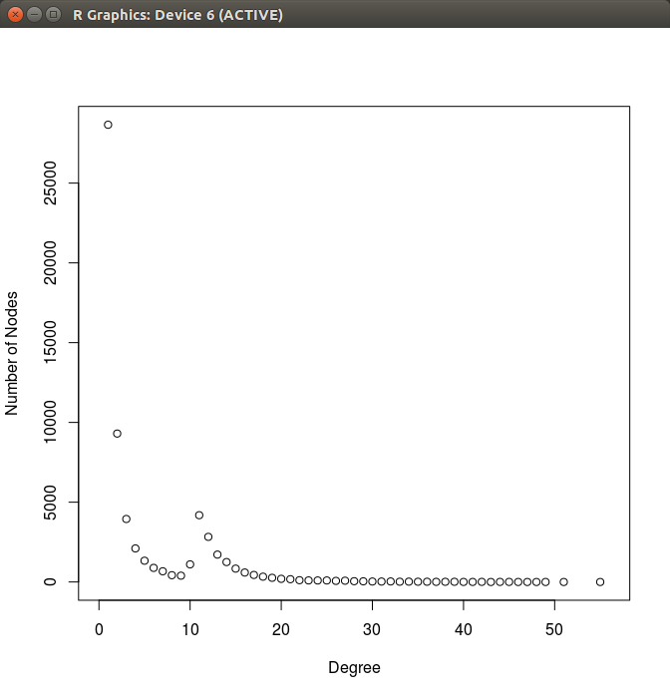

This graph has a few of outliers with respect to the power-law curve, however since it does maintain the shape; this **could** qualify for being a **scale free graph**.

1. roadNet-PA

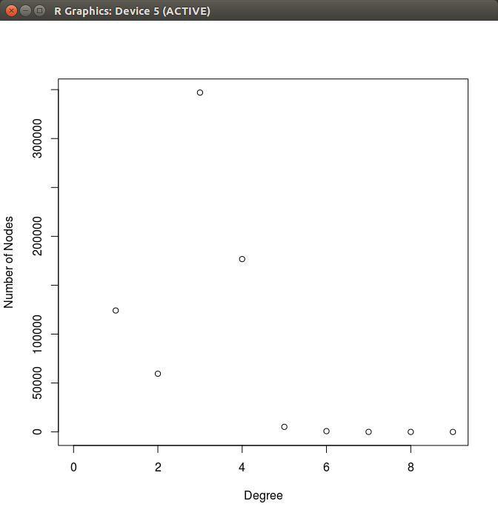Although the points to the right are all low compared to the ones on the left, there are quite a lot of points are outliers. But considering that it does follow the power-law curve in the shape, it **could be** called a **scale free graph.**

**Problem 3.2.**

1. Random graph 1

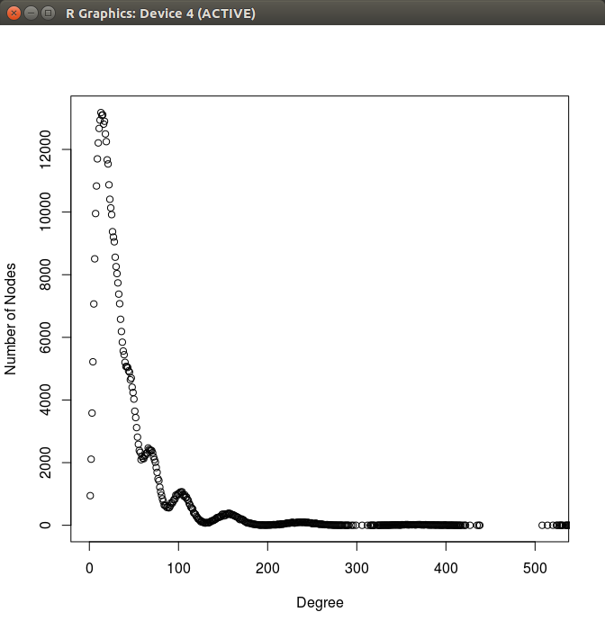

It does have the shape of the power-law curve, however considering the points to the extreme left which are a lot in number; this **cannot** be called a **scale-free graph**

1. Random graph 2

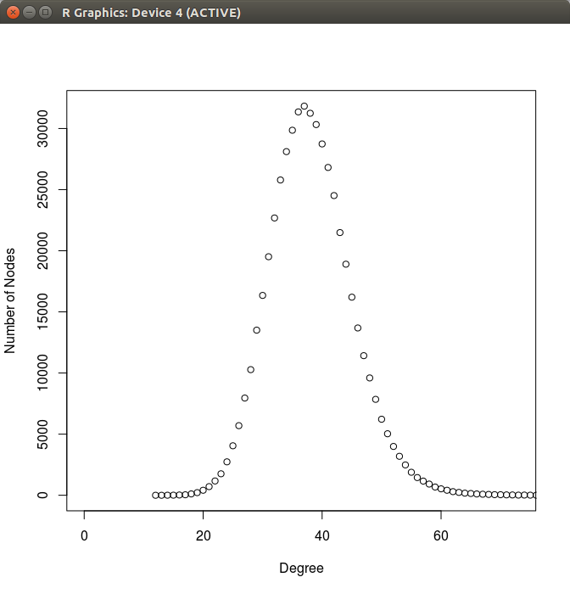

This clearly is not a **scale-free graph.** The shape corresponds to a bell curve

1. Random graph 3

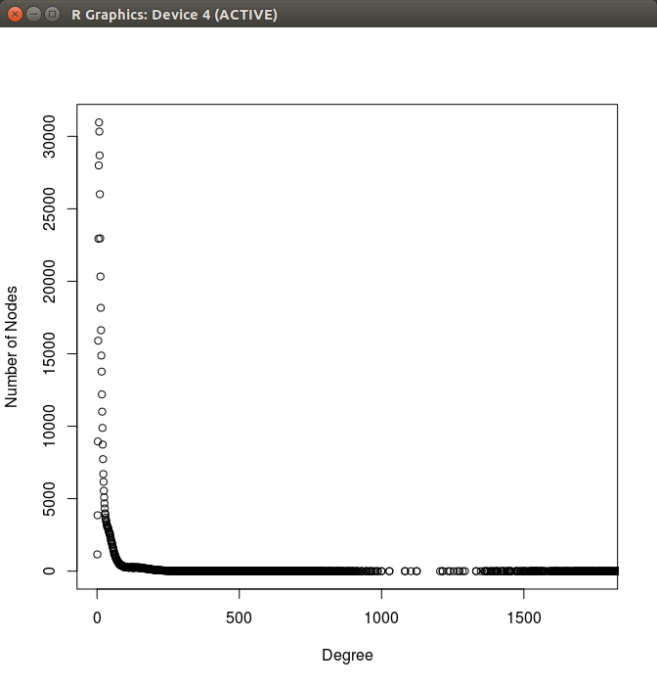

This follows the power-law curve is definitely a **scale-free graph.**